Comparing Correlation Coefficients, Slopes, and Intercepts©

Two Independent Samples
H∅: ρ₁ = ρ₂
If you want to test the null hypothesis that the correlation between X and Y in one population is the same as the correlation between X and Y in another population, you can use the procedure developed by R. A. Fisher in 1921 (On the probable error of a coefficient of correlation deduced from a small sample, Metron, 1, 3-32).
First, transform each of the two correlation coefficients in this fashion:
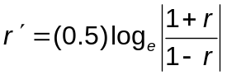
Second, compute the test statistic this way:
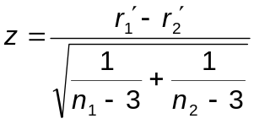
Third, obtain p for the computed z.
Consider the research reported in by Wuensch, K. L., Jenkins, K. W., & Poteat, G. M. (2002). Misanthropy, idealism, and attitudes towards animals. Anthrozoös, 15, 139-149.
The relationship between misanthropy and support for animal rights was compared between two different groups of persons – persons who scored high on Forsyth’s measure of ethical idealism, and persons who did not score high on that instrument. For 91 nonidealists, the correlation between misanthropy and support for animal rights was .3639. For 63 idealists the correlation was .0205. The test statistic, 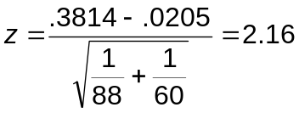, p = .031, leading to the conclusion that the correlation in nonidealists is significantly higher than it is in idealists.
See the pdf document Bivariate Correlation Analyses and Comparisons authored by Calvin P. Garbin of the Department of Psychology at the University of Nebraska. Dr. Garbin has also made available a program for conducting (FZT.exe) for conducting this Fisher’s z test.
If you are going to compare correlation coefficients, you should also compare slopes. It is quite possible for the slope for predicting Y from X to be different in one population than in another while the correlation between X and Y is identical in the two populations, and it is also quite possible for the correlation between X and Y to be different in one population than in the other while the slopes are identical, as illustrated below:
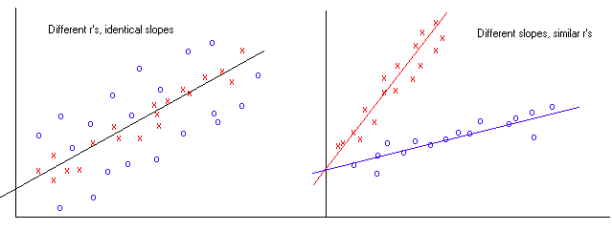

On the left, we can see that the slope is the same for the relationship plotted with blue o’s and that plotted with red x’s, but there is more error in prediction (a smaller Pearson r ) with the blue o’s. For the blue data, the effect of extraneous variables on the predicted variable is greater than it is with the red data.
On the right, we can see that the slope is clearly higher with the red x’s than with the blue o’s, but the Pearson r is about the same for both sets of data. We can predict equally well in both groups, but the Y variable increases much more rapidly with the X variable in the red group than in the blue.
H∅: b₁ = b₂
Let us test the null hypothesis that the slope for predicting support for animal rights from misanthropy is the same in nonidealists as it is in idealists.
First we conduct the two regression analyses, one using the data from nonidealists, the other using the data from the idealists. Here are the basic statistics:
Group | Intercept | Slope | SE_{slope} | SSE | SD_{X} | n
Nonidealists | 1.626 | .3001 | .08140 | 24.0554 | .6732 | 91
Idealists | 2.404 | .0153 | .09594 | 15.6841 | .6712 | 63

The test statistic is Student’s t, computed as the difference between the two slopes divided by the standard error of the difference between the slopes, that is, 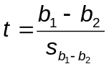 on (N – 4) degrees of freedom.
If your regression program gives you the standard error of the slope (both SAS and SPSS do), the standard error of the difference between the two slopes is most easily computed as
Or, if you just love doing arithmetic, you can first find the pooled residual variance,
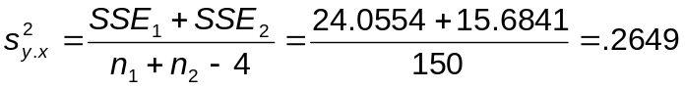,
and then compute the standard error of the difference between slopes as
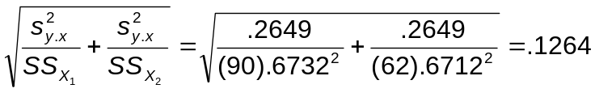, within rounding error of what we got above.
Now we can compute the test statistic: 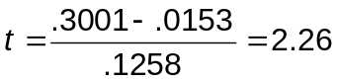.
This is significant on 150 df (p = .025), so we conclude that the slope in nonidealists is significantly higher than that in idealists.
Please note that the test on slopes uses a pooled error term. If the variance in the dependent variable is much greater in one group than in the other, there are alternative methods. See Kleinbaum and Kupper (1978, Applied Regression Analysis and Other Multivariable Methods, Boston: Duxbury, pages 101 & 102) for a large (each sample n > 25) samples test, and K & K page 192 for a reference on other alternatives to pooling.
H∅: a₁ = a₂
The regression lines (one for nonidealists, the other for idealists) for predicting support for animal rights from misanthropy could also differ in intercepts. Here is how to test the null hypothesis that the intercepts are identical:
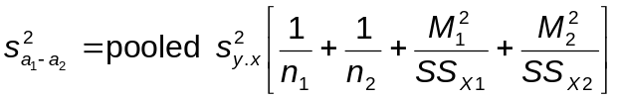
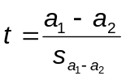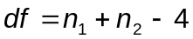
M₁ and M₂ are the means on the predictor variable for the two groups (nonidealists and idealists). If you ever need a large sample test that does not require homogeneity of variance, see K & K pages 104 and 105.
For our data,
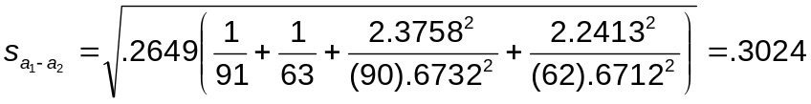, and
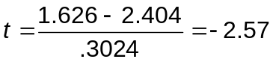. On 150 df, p = .011. The intercept in idealists is significantly higher than in nonidealists.

Links
Misanthropy, Idealism, and Attitudes About Animals – summary of the research used to illustrate comparing two independent samples.
Correlation and Regression Analysis: SAS – using SAS to conduct these regression analyses.

Potthoff Analysis
A more sophisticated way to test these hypotheses would be to create K-1 dichotomous “dummy variables” to code the K samples and use those dummy variables and the interactions between those dummy variables and our predictor(s) as independent variables in a multiple regression. For our problem, we would need only one dummy variable (since K = 2), the dichotomous variable coding level of idealism. Our predictors would then be idealism, misanthropy, and idealism x misanthropy (an interaction term). Complete details on this method (also known as the Potthoff method) are in Chapter 13 of K & K. We shall do this type of analysis when we cover multiple regression in detail in a subsequent course. If you just cannot wait until then, see my document Comparing Regression Lines From Independent Samples .

Correlated Samples
H∅: ρ_{WX} = ρ_{WY}
If you wish to compare the correlation between one pair of variables with that between a second, overlapping pair of variables (for example, when comparing the correlation between one IQ test and grades with the correlation between a second IQ test and grades), you can use Williams’ procedure explained in our textbook -- pages 280-281 of Howell, D. C. (2002), Statistical Methods for Psychology, 5th edition, Duxbury. It is assumed that the correlations for both pairs of variables have been computed on the same set of subjects. The traditional test done to compare overlapping correlated correlation coefficients was proposed by Hotelling in 1940, and is still often used, but it has problems. Please see the following article for more details, including an alternate procedure that is said to be superior to Williams’ procedure: Meng, Rosenthal, & Rubin (1992) Comparing correlated correlation coefficients. Psychological Bulletin, 111: 172-175. Also see the pdf document Bivariate Correlation Analyses and Comparisons authored by Calvin P. Garbin of the Department of Psychology at the University of Nebraska. Dr. Garbin has also made available a program for conducting (FZT.exe) for conducting such tests. It will compute both Hotelling’s t and the test recommended by Meng et al., Steiger’s Z.
H∅: ρ_{WX} = ρ_{YZ}
If you wish to compare the correlation between one pair of variables with that between a second (nonoverlapping) pair of variables, read the article by T. E. Raghunathan , R. Rosenthal, and D. B. Rubin (Comparing correlated but nonoverlapping correlations, Psychological Methods, 1996, 1, 178-183). Also, see my example at http://core.ecu.edu/psyc/wuenschk/StatHelp/ZPF.doc .
Return to my Statistics Lessons page.
Copyright 2005, Karl L. Wuensch - All rights reserved.

 Copyright 2005, Karl L. Wuensch - All rights reserved.

